Simple and Fast Linear Space Computation of Longest Common Subsequences
Claus Rick
Information Processing Letters (IPL), Vol. 75, pp. 275-281, 2000
- Exemple
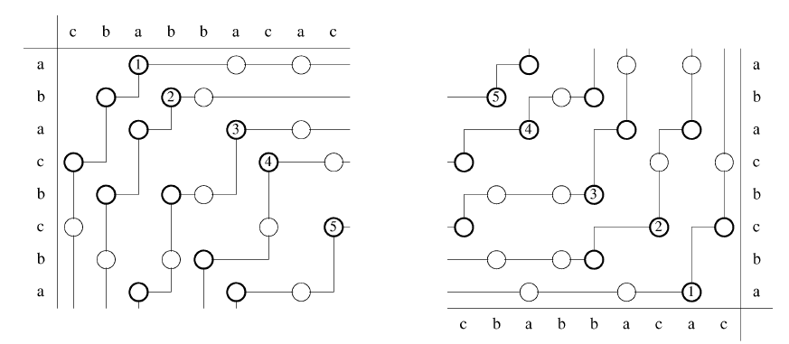
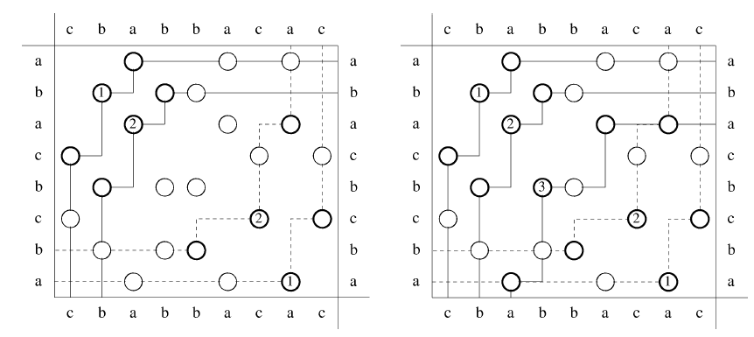
Created by : Jian-Bien Chen
Date : Mar. 29, 2005

